Labs Cgroup

docker run -d --name webserver --memory="1g" --cpus="2" dokken/centos-8

check the stats

docker stats

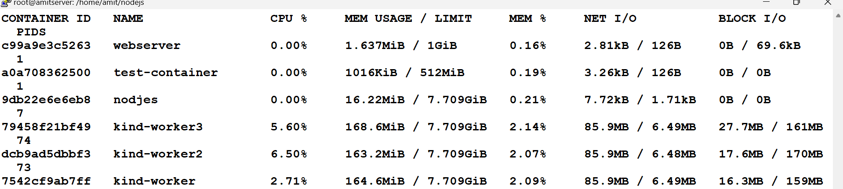

--

Set the memory for the running container

docker update --memory 512m --memory-swap 1g <containerid>

docker stats